1. Overload the + for concatenating the two strings. For e.g “Object” + “oriented” = Objectoriented

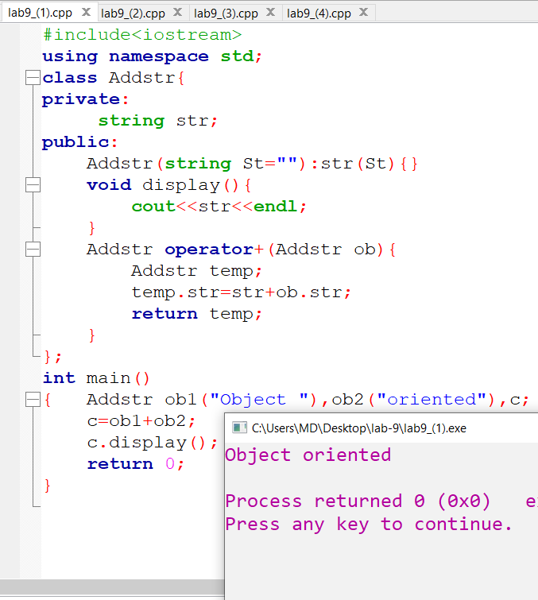

1. Write a friend function for adding the two complex numbers, using single class.

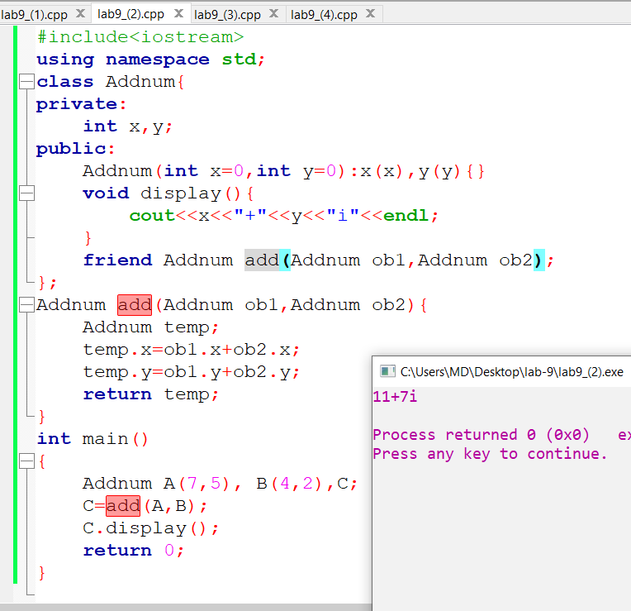

1. Overload the operator + for adding the timings (hr, min, sec) of two clocks.

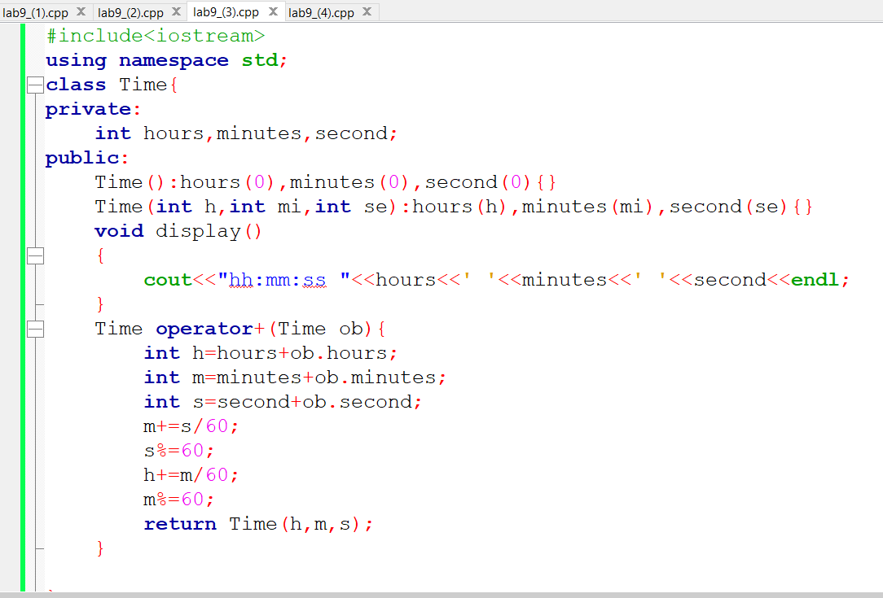

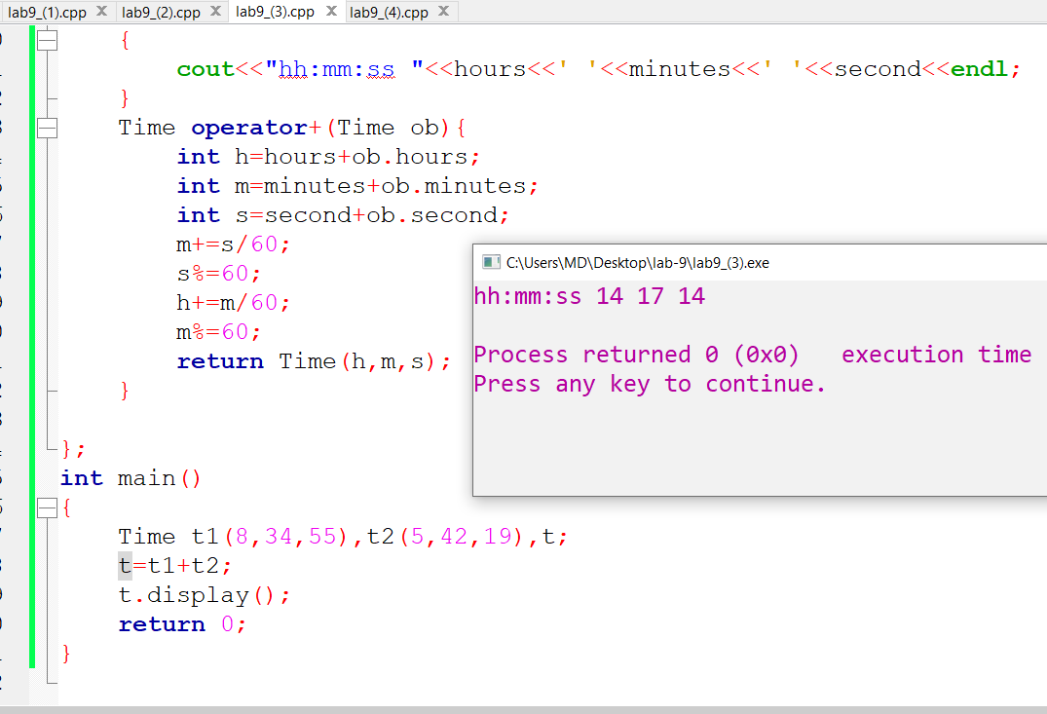

1. Create a class BankAccount representing a bank account with private members balance, accountNumber, and customerName. Implement a friend function transferFunds() that takes two BankAccount objects as arguments and transfers funds from one account to another. Also, make another class BankManager a friend of BankAccount class, which can access the accountNumber and customerName of any BankAccount object. Test your program by creating multiple bank accounts, transferring funds between them, and displaying account information using the BankManager class

